Truncating Styled Text in Columnar List Fields | (All platforms)

In playing around with "table" fields (fields with defined tabstops and whose vGrid property is turned on), I noticed that when I had styled text (bold, for example) in a column in a field, it did not get truncated at the next column boundary.
It turns out that the reason for this is based on the "under-the-hood" method of drawing the table, but there is a work around: If you include a tab inside the style run, it will truncate properly. This is best shown in the graphic below where the tab (shown here in HTML as &#9;) is put both inside and outside the style run:
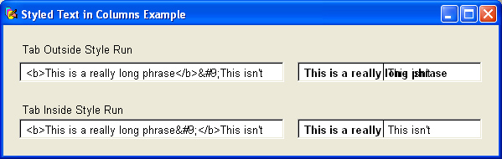
Note that althought I used HTML and setting the htmlText of the columnar fields, the same applies when simply using the mouse to select a range of text and apply a style from a menu or palette, or doing it programmatically. Just make sure you include the tab inside the style run for the column and it will display properly.
Posted 4/14/2003 by Ken Ray

